**Assignment 1 :- Pipeline – Job**

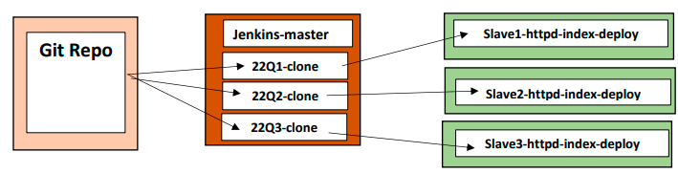

**Step 1 : Launch 4 Instances – 1 Jenkins-Master & 3 Slave Instances as Slave-1, Slave-2 & Slave-3 and Connect**

**# yum install java-1.8.0-openjdk-devel.x86_64 -y**

**# yum install httpd -y**

**# service httpd start**

**# chmod -R 777 /var/www/html**

**Step 2 :- Create Nodes/Agent**

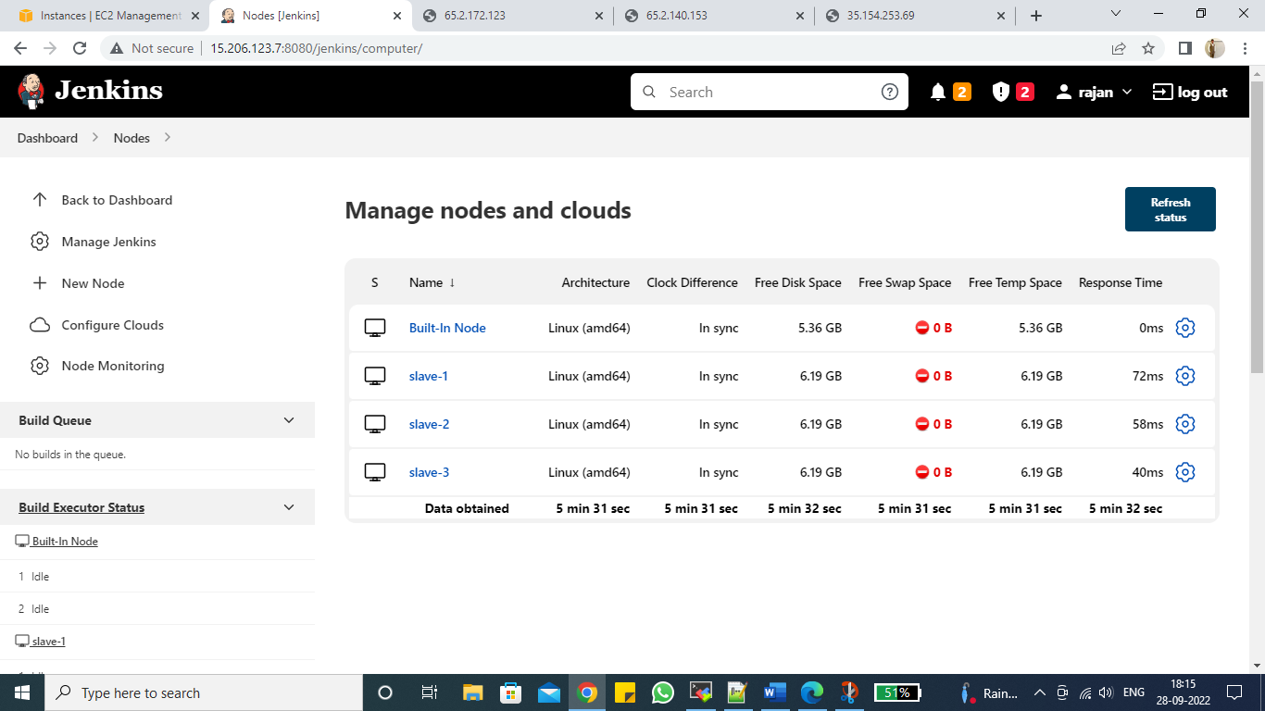

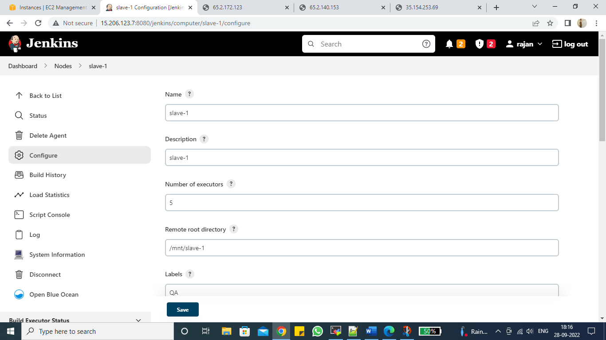

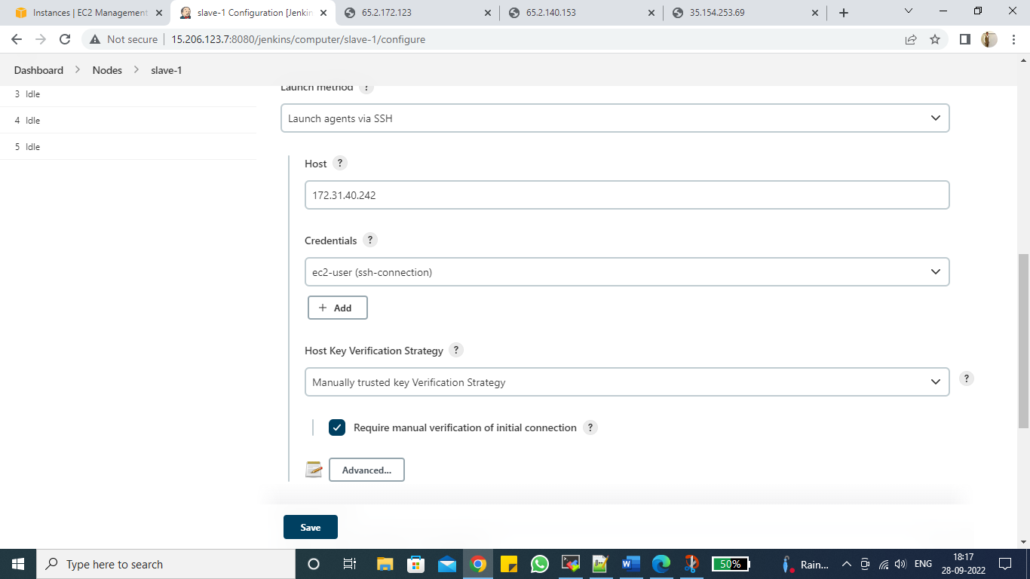

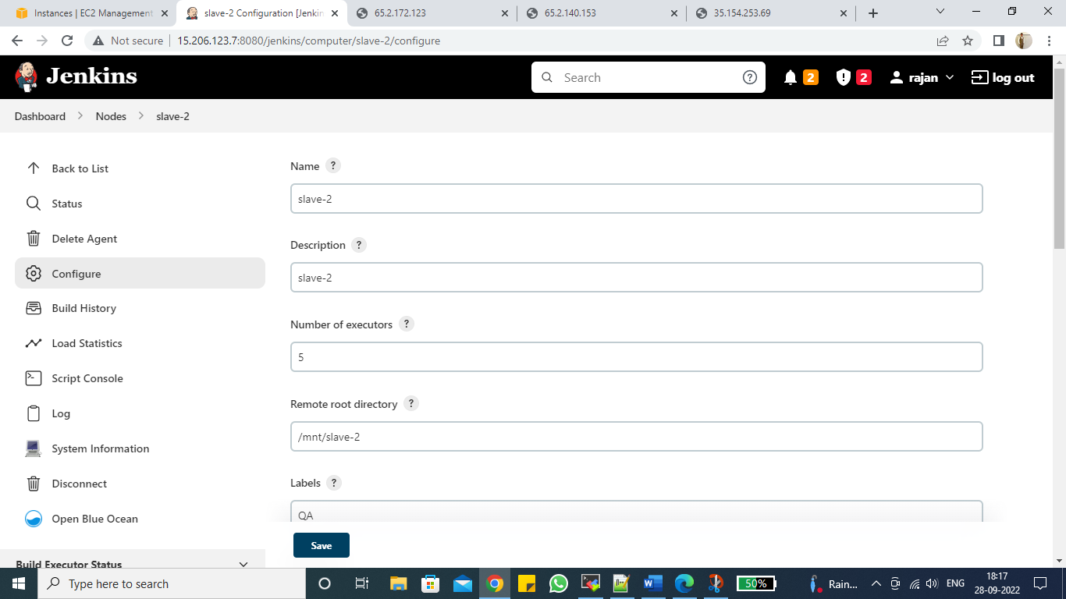

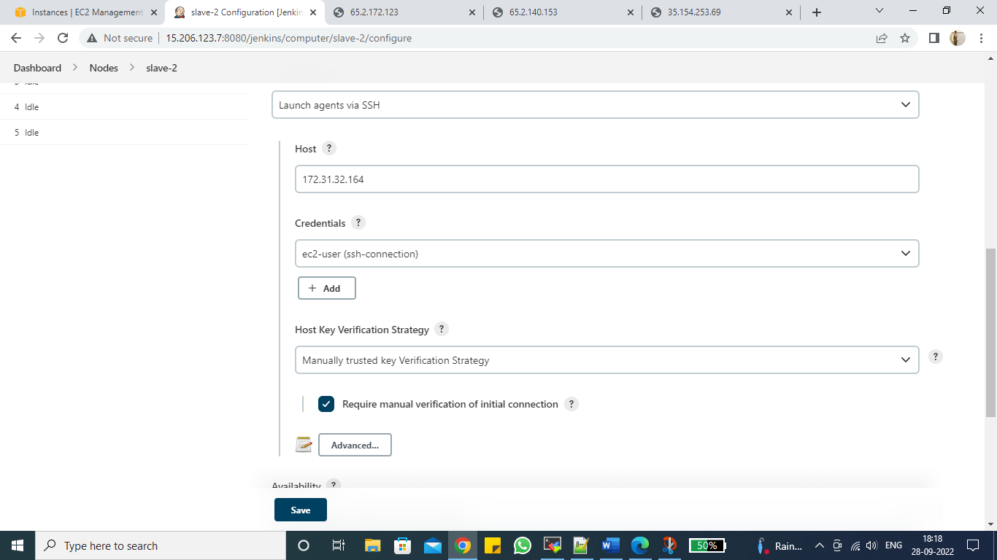

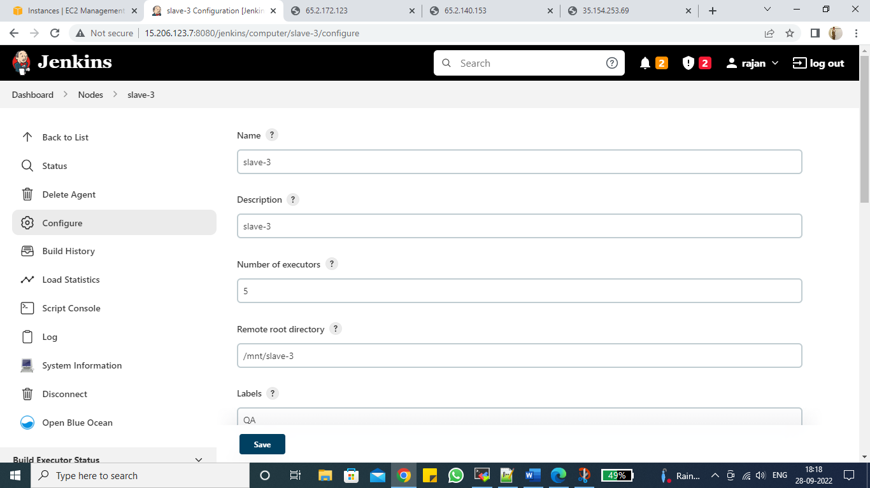

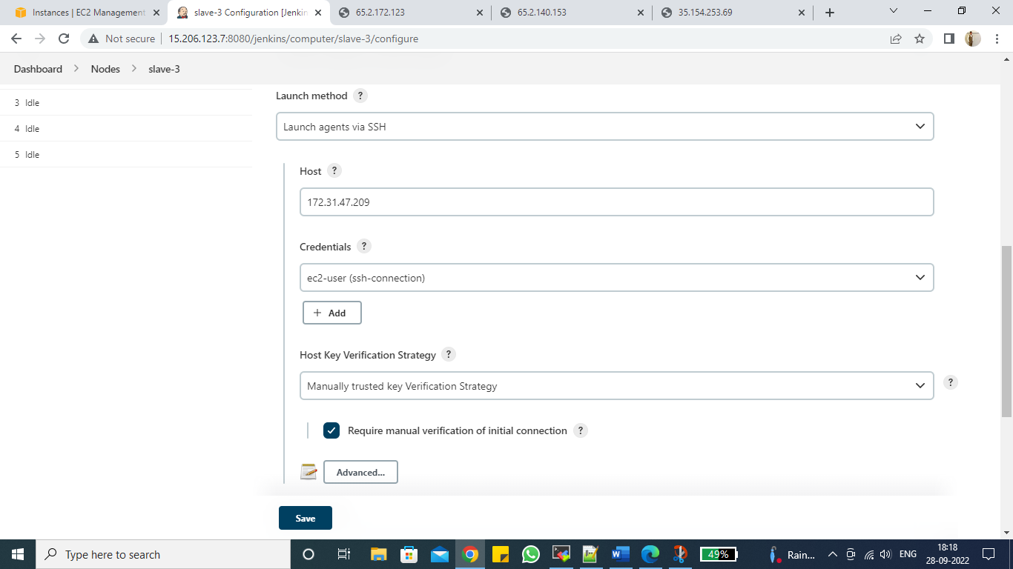

**Step 3 :- Create 1 Pipeline Job**

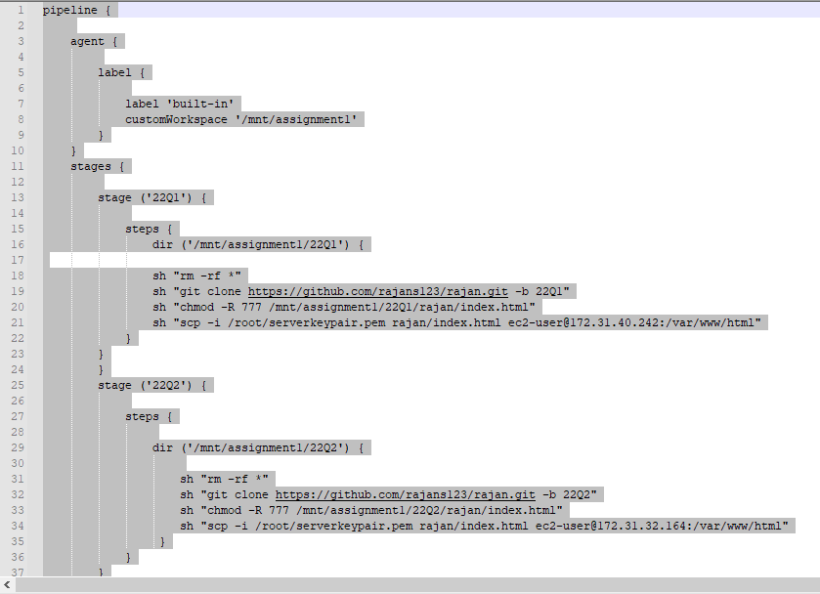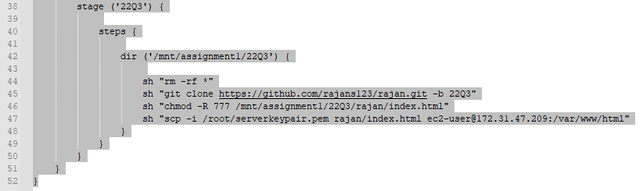

**Step 4 :- Build Job**

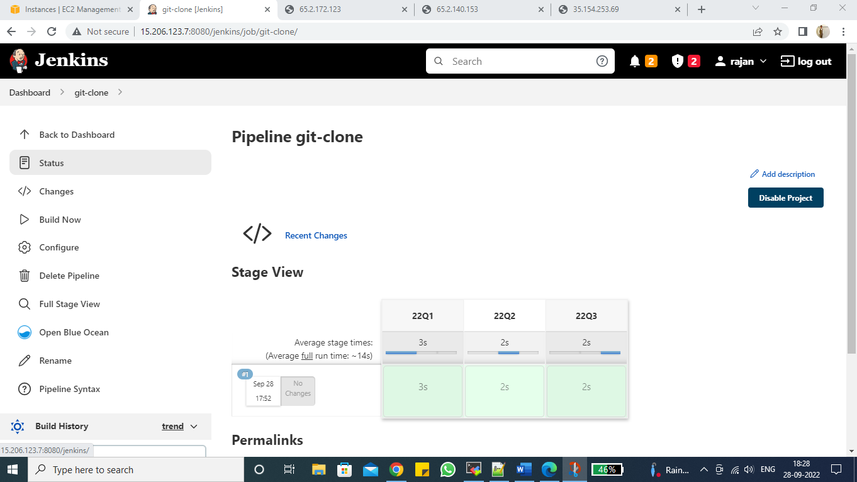

**Step 5 :- Result**

